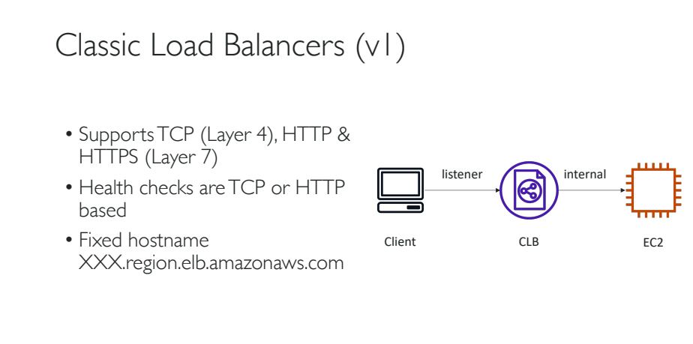

Creating a Classic Load Balancer:

1. Login and start your instance.
2. Copy the public ipv4 and check it httpd page accessibility on the browser.
3. If it works fine, then html page will be displayed on the browser.
4. Now to create an LB, select ‘Load Balancers’ from the left hand side menu and click ‘Create Load Balancer’ button.
5. Click on ‘Create’ button of Classic Load Balancer.
6. Provide ‘Load Balancer Name’
7. Create LB Inside: Select your default VPC.
8. Create an internal load balancer: leave unchecked

NOTE: If it is checked then it will be an internal LB and internal LB’s cannot be accessed publicly.

1. Enable advanced VPC configuration: unchecked
2. Listener Configuration: Explains what our CLB is going to listen

HTTP: 80 is good for Load Balancer Protocol and Instance Protocol

1. Click ‘Assign Security Groups’
2. Create a new ‘Security Group’.
3. Provide SG name and description.

NOTE: This SE will allow anyone to access from port 80 from anywhere to access our LB.

1. Click ‘Configure Security Check’ button. And then go to ‘Configure Health check’.
2. In Configure Health check: Provide appropriate details and options. (Interval time should be greater than the Response Timeout.)
3. Click ‘Add EC2 Instances’ to attach our instance to the newly created CLB.
4. Select the instance, click ‘Add Tags’ and then click ‘Review and Create’.
5. CLB is created and instance is attached to it successfully now.

Using CLB:

1. Go to Load Balancers option from menu and click ‘Instances’ tab

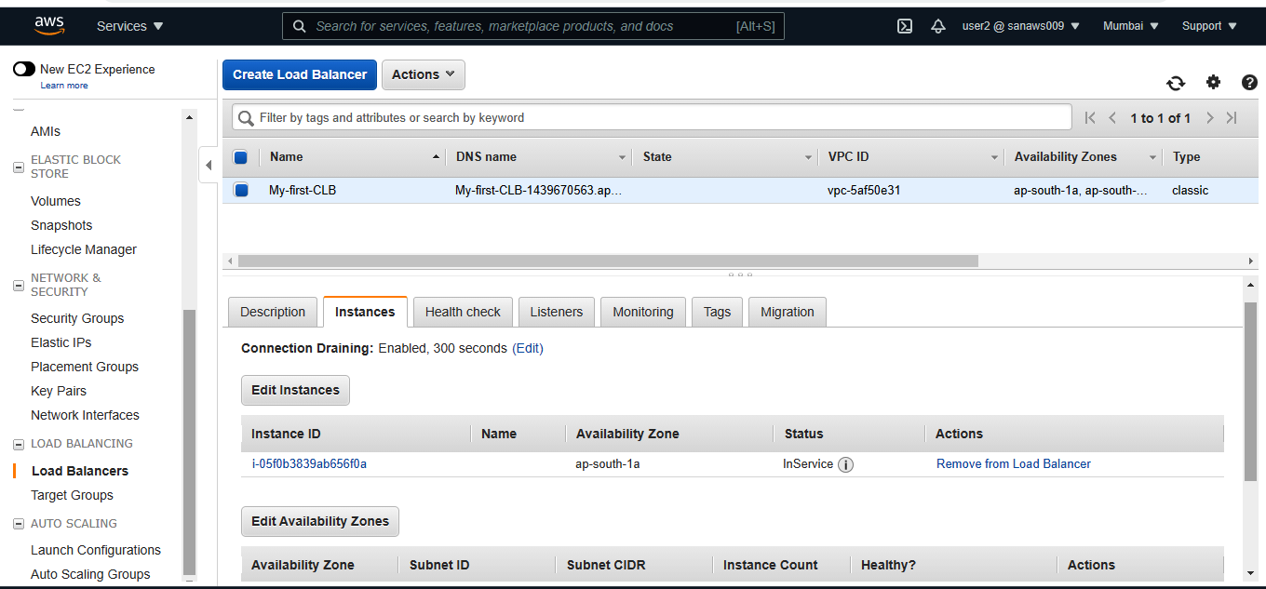

1. We can see the instance status is ‘InService’.
2. This means that the instance is passing the health checks and it is ready.
3. Form the “Description” tab copy the DNS name and paste it on the browsers URL section and hit Enter to see it runs the html code.

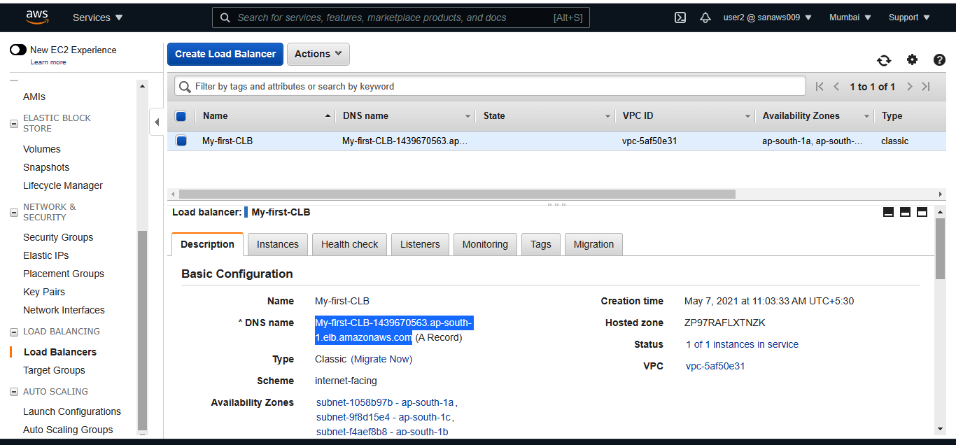

1. This proves that I can access the html page from both my CLB and from the instance.
2. It is always good to access a webpage through a LB, but not through direct instance.
3. To achieve that we are going to stop the html page from accessing through the direct instances ipv4 address.
4. Go to ‘Security Groups’ and edit inbound rules of the instance just like the below example.

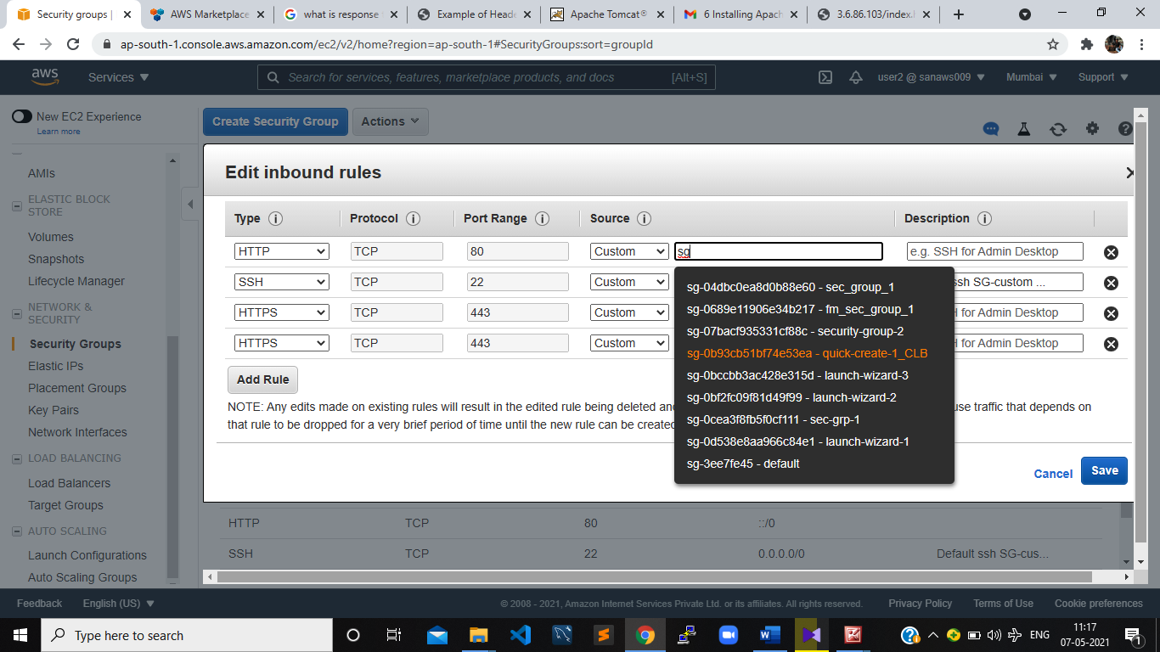

1. In this iam changing the SG of the instance to access port 80 only by the LB.
2. Now go to the browser and try to access index.html by both LB and Instance ipv4. Only LB should work.

Attaching or Launching more Instances to an existing LB:

1. For this go to Instances and select ‘Launch more instances like this’ option.

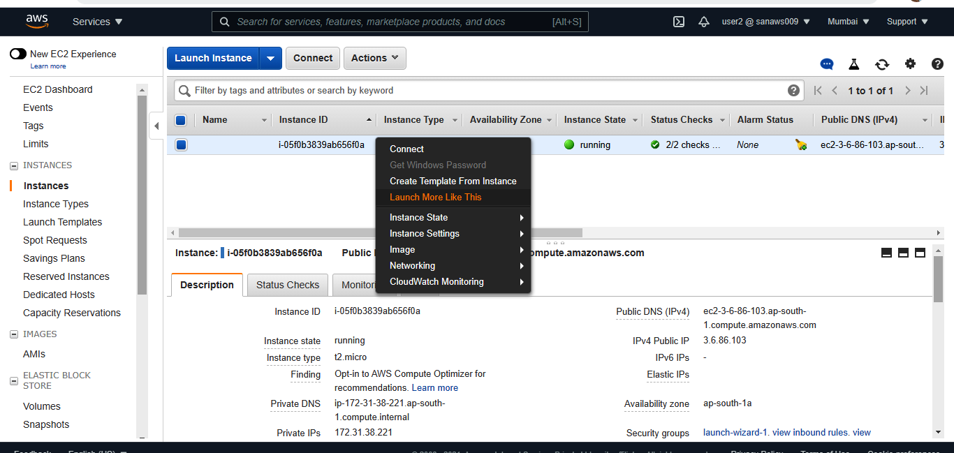

1. And create a new instance which have the same data of new instances.